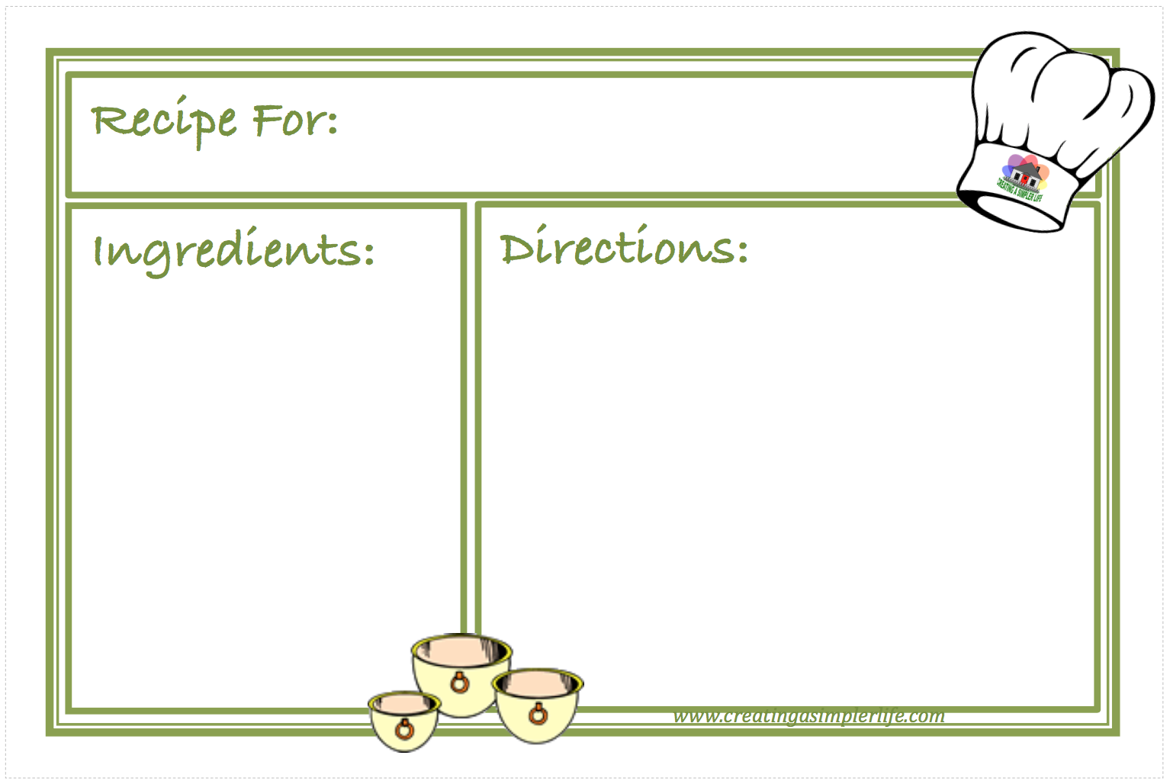

**Type Title of Recipe Here**

List Ingredients Here

Type Directions Here



**Type Title of Recipe Here**

List Ingredients Here

Type Directions Here